Phylum Porifera
(Porous-pore; ferre-to bear)
Members of Porifera, commonly known as sponges, are among the oldest living multicellular animals. They originated in the Precambrian era and have survived successfully up to the present day.
About 8,550 species of poriferans are known worldwide. Sponges reached their greatest diversity during the Cretaceous period. They play an important ecological role by contributing to reef formation and are a major source of biogenic silica, which forms flint deposits.
Sponges are ubiquitous, occurring in oceans across all latitudes of the world.
The scientific study of sponges is known as Parazoology.

General Features
- Level of organisation: Cellular level of organisation
- Germ layers: Diploblastic (functionally)
- Body symmetry: Mostly asymmetrical; some show radial symmetry
- Coelom: Absent (acoelomate)
- Body plan: Cell aggregate body plan
- Digestion: Intracellular digestion
- Respiration: Body surface respiration by diffusion
- Circulation type: Type-I (without blood)
- Circulatory system: Water canal system
- Osmoregulation: Osmoconformers
- Excretion: No excretory organs; wastes removed by diffusion
- Mode of excretion: Aminotelism (ammonia)
- Skeleton: Internal skeletal framework made of spicules or spongin
- Nervous system: Absent
- Metamerism: Absent
- Fertilization: Internal fertilization
- Development: Indirect development with larval stage
- Body temperature: Poikilothermic (ectothermic)

Characteristic Features
- Adult sponges are sessile or sedentary organisms and remain attached to an underwater object called the substratum.
- The body wall contains numerous small inhalant openings called ostia.
- These ostia open into a single, central, and spacious cavity called the spongocoel or paragastric cavity.
- Water leaves the body through one or a few large exhalant openings called the osculum.

Body Wall
- Pinacoderm (dermal layer):
This is the outer cellular layer, made up of:
  - Flattened pinacocytes
  - Oval porocytes, which form the ostia
- Choanoderm (gastral layer):
This is the inner cellular layer, composed of choanocytes (collar cells).
Choanocytes are the characteristic cells of Porifera and are responsible for:
  - Ingestion of food
  - Movement of water
  - Transfer of gametes
  - Differentiation of sex cells
- Mesohyl layer:
This is a non-cellular, jelly-like matrix present between the pinacoderm and choanoderm.
  - It contains spongin fibres and numerous spicules
  - It also has many types of amoebocytes, derived from both pinacoderm and choanoderm
- The body wall is supported by a skeleton made of:
  - Calcareous spicules (calcium carbonate)
  - Siliceous spicules (silica)
  - Spongin fibres
  - Or a combination of these

Canal System (Water Canal System)
- The canal system, also called the water canal system, is a characteristic feature of all Porifera.
- Water enters the sponge body through ostia, passes into the spongocoel, and leaves through the osculum.
- This system helps in:
  - Food gathering
  - Respiration
  - Excretion (mainly ammonia)
  - Transfer of gametes by choanocytes
- The amount of water flowing through a sponge is very large and may reach up to 20,000 times its body volume per day.
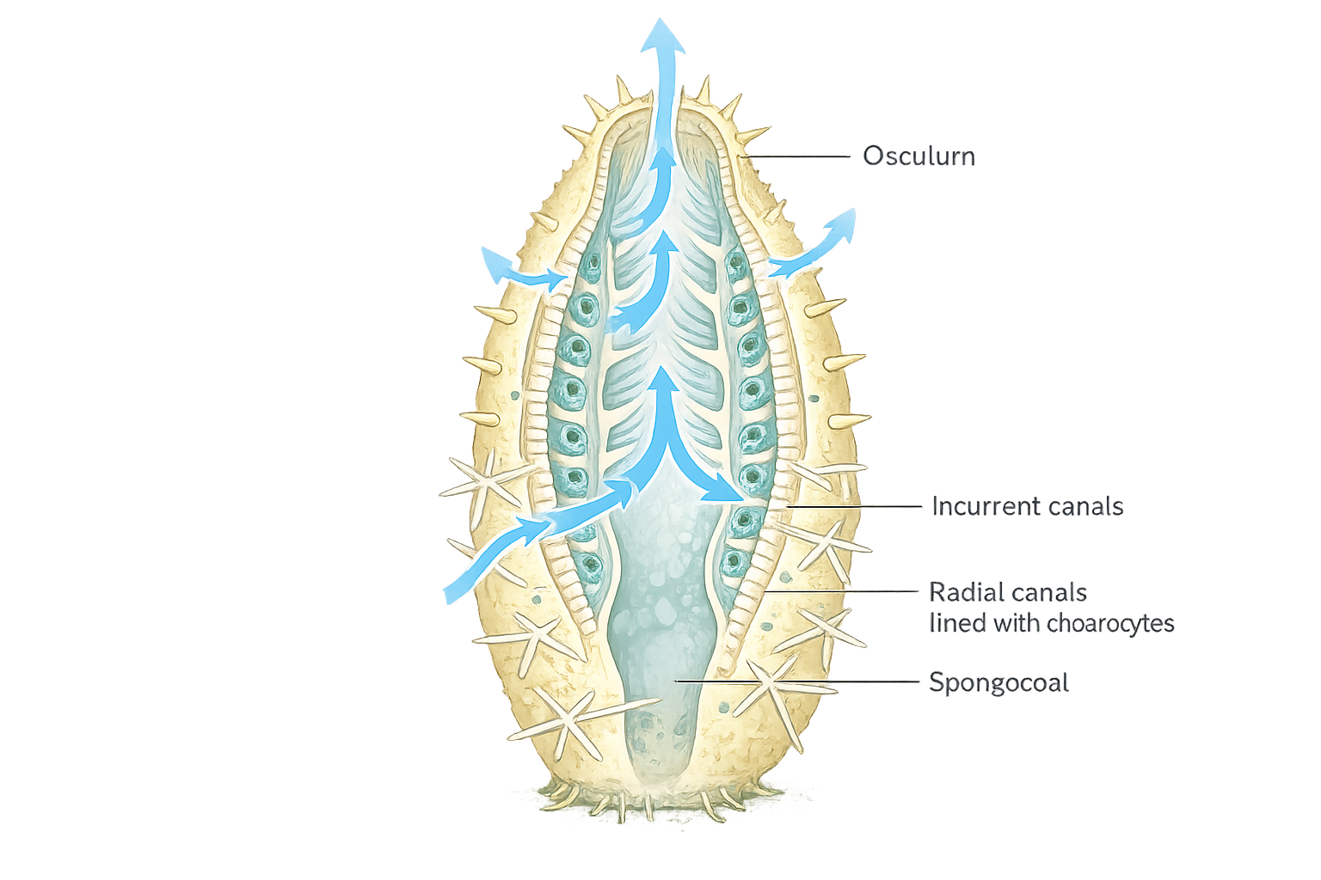

Reproduction in Porifera
Sponges reproduce by both asexual and sexual methods, which helps them survive and spread in different environmental conditions.

Asexual Reproduction
- Asexual reproduction occurs by fragmentation and budding, which may be external or internal.
- Internal buds, produced during unfavourable conditions, are called gemmules.
- Sponges show a high power of regeneration, where even small body fragments can grow into a complete sponge.

Sexual Reproduction
- All sponges are hermaphrodites, meaning the sexes are not separate.
- Therefore, they are described as monoecious or bisexual.
- Sexual reproduction takes place by the formation of haploid (n) male and female gametes.
- Sperms are released into the water from one sponge and are carried by water currents into another sponge.
- Fertilisation occurs inside the body of the sponge, where the sperm fertilises the ovum in situ.
- Development includes intermediate free-swimming larval stages, such as amphiblastula and parenchymula, which help in the dispersal of the species.
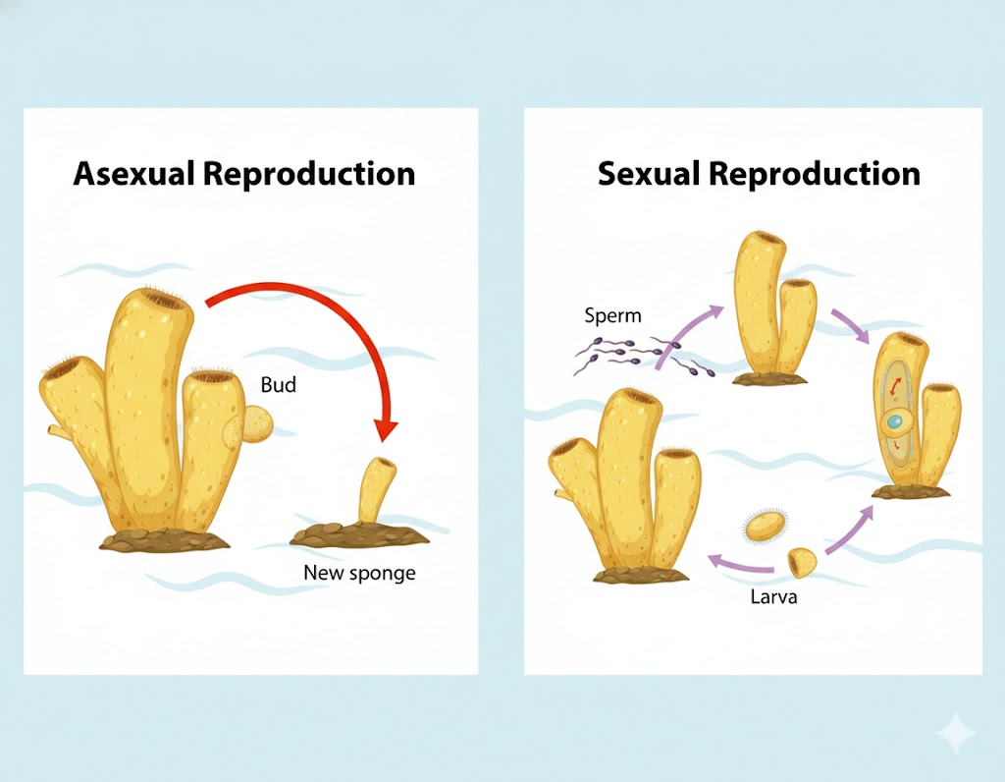

Classification of Phylum Porifera
Based on the nature of the skeleton, phylum Porifera is divided into three main classes.

Class Calcarea
Calcarea, commonly known as calcareous sponges, are characterized by a skeleton made of calcium carbonate spicules.
- The spicules are composed of calcium carbonate.
- These sponges are exclusively marine.
- They are commonly found in shallow coastal waters, though some species occur at greater depths.
- About 400 species of calcareous sponges have been described.
- Class Calcarea is divided into three subclasses based on the structure of their skeleton and spicules.

Class Hexactinellida
Hexactinellida, commonly known as glass sponges, are known for their delicate and intricate skeletons made of silica (glass-like material).
- The skeleton consists of six-rayed siliceous spicules.
- These sponges are exclusively marine.
- They are mainly found in deep-sea environments, usually at depths of 200 metres or more.
- Approximately 600–700 species (around 680 documented species) are known.
- The class Hexactinellida is divided into two subclasses based on skeletal and spicule structure.

Class Demospongiae
Demospongiae, commonly known as demosponges, form the largest class of sponges.
- The skeleton is made of spongin fibres, siliceous spicules (not six-rayed), or both.
- This class includes more than 90% of all sponge species.
- Demosponges are found in a wide range of habitats:
  - Shallow marine waters
  - Deep-sea environments
  - Freshwater ecosystems
- The class is divided into several subclasses, based on skeletal structure, canal systems, and other morphological features.

